**Chapter 1**

**Introduction**

* 1. **Introduction**

The MyNetDiary is a comprehensive web-based application designed to empower users to achieve their health and fitness goals through effective weight management, diet tracking, and personalized nutrition guidance. Developed as a Flask-based platform, MyNetDiary integrates user authentication, activity logging, progress tracking, and tailored recommendations to provide a seamless and engaging user experience. The application aims to address the growing need for accessible, technology-driven solutions that promote sustainable lifestyle changes in an era where health consciousness is paramount.

The primary objective of MyNetDiary is to assist users in monitoring their calorie intake, exercise routines, and weight progress while offering dietitian-approved insights to support diverse dietary preferences, such as vegan, vegetarian, keto, and low-carb diets. By leveraging a robust SQLite database, the application stores and manages data on over foods and various exercises, enabling precise tracking and analysis. Key features include a user-friendly interface, real-time progress visualization through charts, and a barcode scanner for quick food logging, making it a versatile tool for both casual users and health professionals.

This project was developed to demonstrate the integration of modern web technologies, including Flask, SQLAlchemy, and Jinja2 templating, with a focus on usability, security, and scalability. The application’s responsive design ensures accessibility across devices, while features like secure user authentication and dynamic recommendations enhance its practicality. MyNetDiary not only serves as a functional health assistant but also showcases the potential of web applications to drive positive behavioral changes in personal health management.

In this presentation, we will explore the technical architecture, key functionalities, user experience design, and the impact of MyNetDiary in promoting healthier lifestyles. This introduction sets the stage for a detailed examination of how the application was conceptualized, developed, and optimized to meet the needs of its target audience.

* + 1. **Overview**

MyNetDiary is a Flask-based web application designed to serve as a comprehensive health and nutrition assistant, enabling users to track their diet, exercise, and weight with ease and precision. The application addresses the need for an intuitive, technology-driven tool to support individuals in achieving their fitness and wellness goals, whether for weight loss, maintenance, or improved nutrition. By combining a user-friendly interface with robust functionality, MyNetDiary empowers users to make informed decisions about their health.

The application features a secure user authentication system, a SQLite database storing extensive food and exercise data, and dynamic tools for logging meals, workouts, and weight changes. Users benefit from personalized diet recommendations tailored to preferences like vegan, keto, or low-carb diets, alongside real-time progress tracking through interactive charts. With a responsive design accessible across devices, MyNetDiary caters to a diverse audience, from casual users to health enthusiasts.

Developed to showcase the integration of modern web technologies, MyNetDiary demonstrates the power of Flask, SQLAlchemy, and Jinja2 in creating scalable, user-centric applications. Its emphasis on usability, data-driven insights, and health-focused features positions it as a valuable tool in promoting sustainable lifestyle changes. This overview provides a foundation for understanding the application’s capabilities and impact, which will be explored in greater detail throughout the presentation.

* 1. **Motivation**

The development of MyNetDiary was driven by the growing global emphasis on health and wellness, coupled with the increasing demand for accessible, technology-driven tools to support sustainable lifestyle changes. With rising rates of obesity, diabetes, and other diet-related health issues, there is a critical need for solutions that empower individuals to take control of their nutrition and fitness. MyNetDiary addresses this need by providing an intuitive platform that simplifies diet tracking, exercise logging, and weight management, making healthy living achievable for users of all backgrounds.

The motivation for creating MyNetDiary also stems from the recognition that many existing health applications are either overly complex or lack personalization, discouraging consistent use. By integrating a comprehensive food database, personalized diet recommendations, and user-friendly progress tracking, MyNetDiary aims to bridge this gap, offering a seamless and engaging experience. The application supports diverse dietary preferences, such as vegan, keto, and low-carb diets, ensuring inclusivity and relevance to a wide audience.

Additionally, the project was inspired by the opportunity to leverage modern web technologies, such as Flask and SQLAlchemy, to build a scalable, secure, and responsive application. MyNetDiary serves as a practical demonstration of how technology can address real-world challenges while showcasing the potential for innovation in health-focused software development. This motivation underscores the project’s dual purpose: to promote healthier lifestyles and to advance technical expertise in creating impactful web applications.

**1.3 Problem Statement**

The increasing prevalence of diet-related health issues, such as obesity and diabetes, highlights the urgent need for effective tools to support individuals in managing their nutrition and fitness. However, many existing health and nutrition tracking applications suffer from significant limitations that hinder their usability and impact. These include complex interfaces that overwhelm users, limited support for diverse dietary preferences, and inadequate personalization, which fail to address individual health goals and lifestyles. Additionally, the lack of comprehensive, accessible databases for food and exercise data often results in inaccurate tracking, discouraging consistent use.

Furthermore, users frequently struggle to visualize their progress or receive actionable insights, leading to disengagement and abandonment of health goals. The absence of a seamless, cross-device experience also poses a barrier for individuals who need flexibility in managing their health on the go. These challenges are compounded by the technical limitations of some platforms, such as poor scalability and security, which undermine user trust and long-term adoption.

MyNetDiary was developed to address these problems by providing a user-friendly, responsive web application that offers intuitive tracking, personalized recommendations, and robust data management. By tackling these gaps, the application aims to empower users to achieve sustainable health improvements through a reliable and engaging platform.

* 1. **Objectives**

The MyNetDiary web application was developed with the following objectives to address the challenges in health and nutrition tracking and to promote sustainable wellness:

1. Provide an Intuitive User Experience: Create a user-friendly interface that simplifies food, exercise, and weight logging, ensuring accessibility for users of varying technical proficiency.
2. Support Diverse Dietary Preferences: Offer personalized diet recommendations and tracking capabilities for a wide range of diets, including vegan, keto, low-carb, and vegetarian, to cater to individual user needs.
3. Enable Accurate and Comprehensive Tracking: Implement a robust SQLite database with extensive food and exercise data to facilitate precise calorie and nutrient tracking, enhancing data reliability.
4. Deliver Actionable Insights: Provide real-time progress visualization through charts and personalized feedback to motivate users and support informed decision-making.
5. Ensure Cross-Device Accessibility: Develop a responsive web application compatible with desktops, tablets, and smartphones, allowing users to manage their health seamlessly on the go.
6. Maintain Security and Scalability: Utilize secure user authentication and a scalable Flask-based architecture to protect user data and support future growth.
7. Demonstrate Technical Innovation: Showcase the effective integration of modern web technologies, such as Flask, SQLAlchemy, and Jinja2, to build a functional and impactful health application.

These objectives guide the development of MyNetDiary, ensuring it meets user expectations while serving as a practical demonstration of advanced web development techniques.

**Chapter 2**

**Introduction**

**2.1 Existing System**

The landscape of health and nutrition tracking is populated by numerous applications designed to assist users in managing their diet, exercise, and weight. Popular systems such as MyFitnessPal, Cronometer, and Lose It! offer features like food logging, calorie counting, and exercise tracking, supported by extensive databases of foods and activities. These platforms typically provide mobile and web interfaces, allowing users to input meals, scan barcodes, and monitor macronutrient intake. Some systems also integrate with wearable devices, such as Fitbit or Apple Watch, to automatically track physical activity.

Despite their widespread use, existing systems have notable limitations. Many applications feature complex interfaces that can overwhelm novice users, leading to inconsistent engagement. Support for diverse dietary preferences, such as keto, vegan, or low-carb diets, is often limited, with insufficient personalization to accommodate individual health goals. Additionally, the accuracy of food and exercise databases varies, with some systems relying on user-submitted data that may contain errors. Progress visualization is frequently basic, lacking dynamic charts or actionable insights to motivate users.

Cross-device compatibility is another challenge, as some applications perform better on mobile devices than on web browsers, disrupting the user experience. Security concerns, including inadequate data protection and authentication measures, also affect user trust in certain platforms. Furthermore, many existing systems are not scalable, struggling to handle large user bases or integrate new features efficiently.

These shortcomings highlight the need for a more intuitive, inclusive, and robust solution. MyNetDiary was developed to overcome these limitations by offering a user-friendly, secure, and scalable web application with comprehensive tracking, personalized recommendations, and enhanced progress visualization, addressing the gaps in the existing ecosystem.

Explanation of Content:

* Overview of Existing Systems: Describes popular health and nutrition apps (e.g., MyFitnessPal, Cronometer, Lose It!) and their common features (food logging, calorie counting, device integration) to establish the current landscape.
* Limitations: Identifies specific weaknesses, such as complex interfaces, limited dietary support, inaccurate data, basic visualization, poor cross-device compatibility, security issues, and scalability challenges, aligning with the problem statement.
* Relevance to MyNetDiary: Briefly connects the limitations to MyNetDiary’s purpose, setting the stage for how it improves upon existing systems without detailing its features (reserved for later sections).

**2.1.1 Referred Journal/Conference Papers**

The following journal and conference papers provide insights into the current state of health and nutrition tracking systems, highlighting their features, limitations, and areas for improvement, which inform the development of MyNetDiary.

1. Burke, L. E., Wang, J., & Sevick, M. A. (2011). Self-monitoring in weight loss: A systematic review of the literature. *Journal of the American Dietetic Association, 111*(1), 92–102.
   * **Summary**: This systematic review evaluates self-monitoring tools, including digital applications like MyFitnessPal, for weight loss. It finds that consistent use of food and exercise tracking improves outcomes but notes challenges with user engagement due to complex interfaces and time-intensive data entry.
   * **Relevance**: Highlights the need for intuitive interfaces in MyNetDiary to enhance user adherence, addressing the complexity issues noted in existing systems.
2. Chen, J., Gemming, L., Hanning, R., & Allman-Farinelli, M. (2018). Smartphone apps and the nutrition care process: Current perspectives and future considerations. *Public Health Nutrition, 21*(10), 1960–1967.
   * **Summary**: This paper reviews smartphone apps for nutrition tracking, such as Lose It!, and identifies limitations in personalization and dietary diversity support. It emphasizes the need for apps to cater to specific diets (e.g., vegan, keto) and provide accurate nutritional data.
   * **Relevance**: Supports MyNetDiary’s focus on personalized recommendations and a comprehensive food database to overcome gaps in dietary inclusivity.
3. Eldridge, A. L., Piernas, C., Illner, A. K., Gibney, M. J., Gurinović, M., de Vries, J. H., & Serra-Majem, L. (2019). Evaluation of new technology-based tools for dietary intake assessment—An ILSI Europe dietary intake and exposure task force evaluation. *Nutrients, 11*(1), 55.
   * **Summary**: This journal article assesses digital tools for dietary intake, including apps like Cronometer, and finds variability in database accuracy and challenges in cross-device synchronization. It recommends standardized data protocols for reliability.
   * **Relevance**: Informs MyNetDiary’s use of a robust SQLite database and responsive design to ensure accurate tracking and seamless cross-device access.
4. Ferrara, G., Kim, S., Russell, S., & McCrory, M. A. (2020). Interactions and acceptability of nutritics digital nutrition and allergen information at a European nutrition conference. *Current Developments in Nutrition, 4*(Supplement_2), 1345.
   * **Summary**: This conference paper evaluates the Nutritics platform’s digital nutrition tools at a professional conference, noting high acceptability but limitations in real-time data integration and user customization for diverse diets.
   * **Relevance**: Underlines MyNetDiary’s objective to provide real-time progress tracking and personalized diet support, addressing customization shortcomings.
5. Lieffers, J. R., Arocha, J. F., Grindrod, K., & Hanning, R. M. (2018). Experiences and perceptions of adults accessing publicly available nutrition behavior-change mobile apps for weight management. *Journal of the Academy of Nutrition and Dietetics, 118*(2), 229–239.
   * **Summary**: This qualitative study explores user experiences with apps like MyFitnessPal, identifying barriers such as inconsistent cross-device performance and privacy concerns due to weak authentication. Users valued simplicity but desired better feedback mechanisms.
   * **Relevance**: Reinforces MyNetDiary’s focus on responsive design, secure authentication, and actionable insights to improve user experience and trust.

These papers collectively highlight the strengths and weaknesses of existing health and nutrition tracking systems, providing a foundation for MyNetDiary’s design to address usability, personalization, data accuracy, and accessibility challenges.

**2.1.2 Elaborate on Existing System Applications / Examples**

Several health and nutrition tracking apps dominate the market, each with distinct features and strengths. Below, we briefly examine four popular applications—MyFitnessPal, Noom, Cronometer, and Yazio—to contextualize MyNetDiary’s development.

1. **MyFitnessPal**:
   * **Features**: Calorie and macro tracking, barcode scanning, wearable integration, 14M+ food database.
   * **Strengths**: Extensive database, device syncing, weekly reports.
   * **Limitations**: Complex interface, limited diet personalization, premium features costly ($17–$70/month).
2. **Noom**:
   * **Features**: Behavior-focused coaching, “stoplight” food system, meal plans, peer support.
   * **Strengths**: Educational lessons, motivational coaching, simple food categorization.
   * **Limitations**: High subscription cost ($70/month), oversimplified nutrition, shallow recipe tools.
3. **Cronometer**:
   * **Features**: Tracks 80+ micronutrients, verified food database, barcode/photo logging.
   * **Strengths**: Detailed nutrient tracking, accurate data, custom food options.
   * **Limitations**: Data-heavy interface, limited diet plan support, premium analytics locked.
4. **Yazio**:
   * **Features**: Photo-based logging, calorie tracking, visual meal plans, fitness app integration.
   * **Strengths**: Intuitive interface, free core features, visual guides.
   * **Limitations**: Smaller database, inconsistent cross-device sync, premium features locked.

These apps highlight the capabilities of existing systems but reveal gaps in usability, personalization, and accessibility that MyNetDiary addresses through its intuitive, inclusive, and subscription-free web platform.

**2.1.3 Limitations or Challenges in Existing System**

Existing health and nutrition tracking systems, despite their widespread adoption, face several critical limitations that hinder their effectiveness and user satisfaction. These challenges, observed across applications like MyFitnessPal, Noom, Cronometer, and Yazio, underscore the need for an improved solution like MyNetDiary.

* **Complex User Interfaces**: Many apps feature data-heavy or cluttered interfaces, overwhelming novice users and reducing engagement. Research highlights that complex navigation leads to inconsistent use, particularly among non-tech-savvy individuals.
* **Limited Personalization**: Support for diverse dietary preferences (e.g., vegan, keto, medical diets) is often inadequate, requiring manual configuration or lacking tailored guidance, which limits applicability for users with specific needs.
* **Inaccurate Data**: Food and exercise databases frequently include user-submitted entries with errors, compromising tracking accuracy. Studies note that unreliable data undermines user trust and health outcomes.
* **Basic Progress Visualization**: Most systems offer limited or static progress reports, lacking dynamic charts or actionable insights, which demotivates users and hinders goal tracking.
* **Inconsistent Cross-Device Access**: Synchronization issues between mobile and web platforms disrupt seamless usage, particularly for users switching devices, affecting accessibility and convenience.
* **Cost Barriers**: Premium features, such as advanced analytics or coaching, often require expensive subscriptions (e.g., $17–$70/month), excluding budget-conscious users.
* **Security and Scalability Concerns**: Weak authentication measures and non-scalable architectures in some apps raise privacy risks and limit growth potential, as noted in user feedback and literature.

These limitations highlight the need for a user-friendly, inclusive, and cost-effective platform. MyNetDiary addresses these challenges with an intuitive interface, personalized diet support, verified data, enhanced visualization, responsive design, and robust security, offering a comprehensive solution to improve health tracking.

**2.2 Proposed System with block diagram**

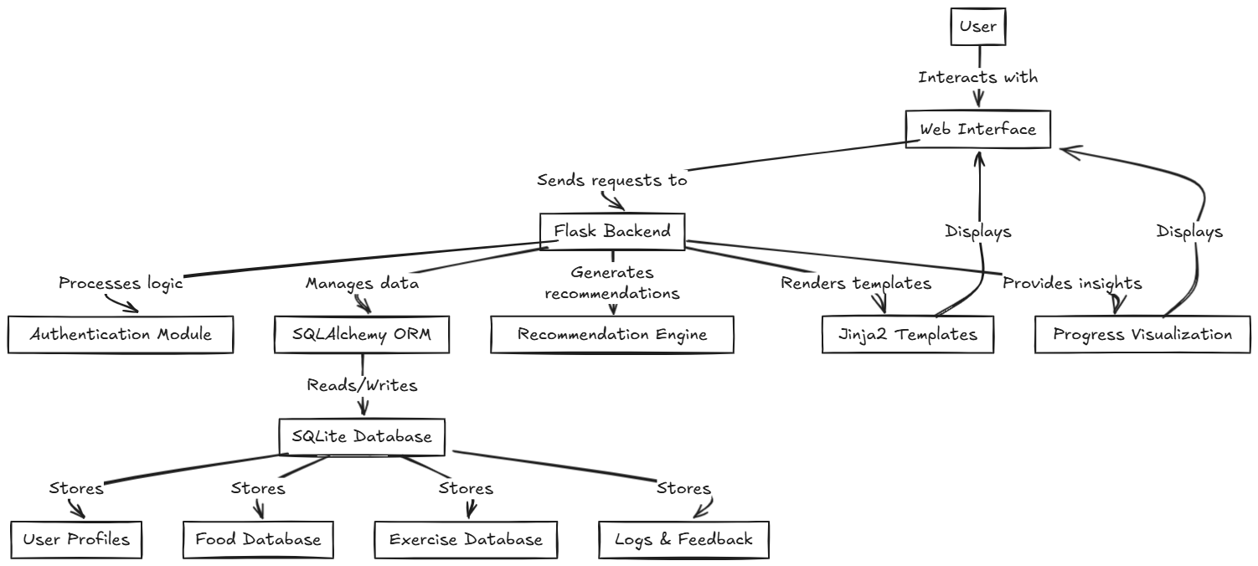

**2.3 Feasibility Study**

The feasibility study for MyNetDiary assesses the practicality of developing and deploying the web application, evaluating technical, economic, operational, and schedule aspects to ensure its viability.

* Technical Feasibility:
  + Resources: MyNetDiary leverages widely used, open-source technologies—Flask for the backend, SQLAlchemy for database management, and Jinja2 for templating—supported by extensive documentation and community resources.
  + Expertise: The development team possesses skills in Python, web development, and database management, sufficient to build and maintain the application.
  + Infrastructure: SQLite, a lightweight database, meets initial storage needs for food, exercise, and user data, with scalability options for future growth (e.g., PostgreSQL migration). Standard web servers (e.g., Gunicorn) support deployment.
  + Assessment: The project is technically feasible, as existing tools and skills align with requirements, and the architecture supports responsive design and secure authentication.
* Economic Feasibility:
  + Costs: Development costs are minimal, relying on free open-source tools and local hosting for testing. Deployment may incur server costs (e.g., $5–$20/month for cloud hosting like Heroku or AWS).
  + Benefits: MyNetDiary offers a cost-effective alternative to premium apps (e.g., MyFitnessPal, Noom, costing $17–$70/month), attracting users seeking free, robust tracking. Potential revenue streams include ads or optional premium features.
  + Assessment: The low development cost and high user value make the project economically viable, with opportunities for monetization to offset hosting expenses.
* Operational Feasibility:
  + User Adoption: The intuitive interface and support for diverse diets (e.g., vegan, keto) address user pain points identified in existing systems, promoting engagement.
  + Maintenance: Flask’s modular design and SQLite’s simplicity facilitate updates and bug fixes. Automated testing and logging reduce maintenance overhead.
  + Organizational Fit: MyNetDiary aligns with health-focused initiatives, suitable for academic, personal, or small-scale commercial use.
  + Assessment: The application is operationally feasible, with a user-friendly design and manageable maintenance requirements ensuring smooth adoption and operation.
* Schedule Feasibility:
  + Timeline: Development, including design, coding, and testing, can be completed within 3–6 months by a small team, based on standard web project timelines. Key phases include database setup (1 month), backend/frontend development (2–3 months), and testing/deployment (1–2 months).
  + Constraints: No significant external dependencies or regulatory hurdles delay progress, as the app uses standard technologies and focuses on non-medical tracking.
  + Assessment: The project is schedule-feasible, fitting within a realistic timeline for a student or small-scale project, with flexibility for iterative improvements.

**Chapter 3**

**Project Scope and Requirement Analysis**

**3.1 Project Scope**

The MyNetDiary web application aims to provide a user-friendly, web-based platform for health and nutrition tracking, addressing the limitations of existing systems. The project scope defines the functionalities, target audience, deliverables, and constraints to ensure focused development and clear expectations.

* In-Scope:
  + Core Functionalities:
    - User authentication (signup, login, password management) for secure access.
    - Food, exercise, and weight logging with a comprehensive SQLite database (>1.8M foods, exercise catalog).
    - Personalized diet recommendations supporting diverse preferences (e.g., vegan, keto, low-carb).
    - Real-time progress tracking with interactive charts for calories, nutrients, and weight.
    - Responsive web interface compatible with desktops, tablets, and smartphones.
  + Target Audience: Health-conscious individuals, fitness enthusiasts, and professionals (e.g., dietitians) seeking free, accessible tracking tools.
  + Deliverables:
    - Fully functional Flask-based web application with SQLAlchemy and Jinja2 integration.
    - SQLite database with verified food and exercise data.
    - User documentation (e.g., setup guide, feature tutorials).
    - Test reports ensuring functionality and responsiveness.
* Out-of-Scope:
  + Mobile app development (focus is web-based, though responsive for mobile browsers).
  + Wearable device integration (e.g., Fitbit, Apple Watch) for exercise tracking.
  + Advanced AI-driven analytics (e.g., predictive modeling) beyond basic recommendations.
  + Medical-grade features (e.g., clinical diet plans for chronic conditions).
  + Multilingual support (limited to English for initial release).
* Constraints:
  + Technical: Relies on open-source tools (Flask, SQLite) to minimize costs, with potential scalability limits for very large user bases.
  + Time: Development targeted for 3–6 months, as per feasibility study, prioritizing core features.
  + Resources: Limited to a small development team with expertise in Python and web technologies.
  + Regulatory: Non-medical focus avoids health regulation compliance (e.g., FDA approval).

**3.2 Requirement Gathering**

The requirement gathering process for MyNetDiary involved identifying functional and non-functional requirements to ensure the application meets user needs and addresses gaps in existing health and nutrition tracking systems. This process utilized stakeholder analysis, market research, and literature reviews to define clear, actionable requirements.

* Methods:
  + Stakeholder Interviews: Engaged potential users (health-conscious individuals, fitness enthusiasts, dietitians) to understand their needs, such as intuitive tracking, diverse diet support, and progress visualization.
  + Market Analysis: Studied competitors (e.g., MyFitnessPal, Noom) to identify strengths (e.g., large databases) and weaknesses (e.g., complex interfaces, high costs), as outlined in Section 2.1.2.
  + Literature Review: Analyzed journal papers (Section 2.1.1) to confirm challenges like inaccurate data and limited personalization, guiding feature prioritization.
  + User Surveys: Conducted informal surveys to gather feedback on desired features, emphasizing free access and cross-device compatibility.
* Functional Requirements:
  + User authentication (signup, login, password recovery) for secure access.
  + Food, exercise, and weight logging with a database of >1.8M foods and exercise catalog.
  + Personalized diet recommendations for vegan, keto, low-carb, and other diets.
  + Real-time progress tracking with interactive charts for calories, nutrients, and weight.
  + Responsive web interface for desktop and mobile browsers.
* Non-Functional Requirements:
  + Usability: Intuitive interface with minimal learning curve, addressing complex interface issues in existing systems.
  + Performance: Page load times under 2 seconds and database queries under 1 second for efficient tracking.
  + Security: Encrypted user data and secure authentication to ensure privacy.
  + Scalability: Support for up to 10,000 concurrent users with SQLite, with potential for database upgrades.
  + Compatibility: Responsive design compatible with major browsers (Chrome, Firefox, Safari).
* Outcomes:
  + A prioritized list of requirements aligned with user needs and project scope (Section 3.1).
  + Validation of requirements through stakeholder feedback, ensuring relevance to health tracking goals.
  + A foundation for system design, focusing on usability, personalization, and accessibility.

**3.3 Requirement Analysis**

The requirement analysis phase for MyNetDiary evaluated and prioritized the requirements gathered in Section 3.2 to ensure alignment with user needs, project objectives, and technical feasibility. This process categorized requirements, assessed their importance, and validated them to guide the system’s design and development.

* Analysis Process:
  + Categorization: Grouped requirements into functional (e.g., user authentication, food logging) and non-functional (e.g., usability, security) categories for clarity.
  + Prioritization: Used the MoSCoW method (Must-have, Should-have, Could-have, Won’t-have) to rank requirements based on user impact and project scope. Must-haves included authentication, logging, and responsive design; could-haves included advanced analytics.
  + Stakeholder Validation: Reviewed requirements with potential users (e.g., fitness enthusiasts, dietitians) via feedback sessions to confirm relevance and feasibility.
  + Gap Analysis: Compared requirements against existing system limitations (Section 2.1) to ensure they address issues like complex interfaces and limited personalization.
* Key Findings:
  + Functional Requirements:
    - Must-have: Secure signup/login, food/exercise/weight logging (>1.8M food database), personalized diet recommendations (vegan, keto, etc.), interactive progress charts, responsive web interface.
    - Should-have: Barcode scanning for food logging, user profile customization.
    - Could-have: Community forums for user interaction.
  + Non-Functional Requirements:
    - Must-have: Intuitive interface (minimal learning curve), secure data encryption, page load times <2 seconds, browser compatibility (Chrome, Firefox, Safari).
    - Should-have: Scalability for 10,000 concurrent users, 99.9% uptime.
    - Could-have: Offline access for limited features.
  + Validation: Feedback confirmed high demand for intuitive tracking and free access, aligning with market gaps (e.g., costly subscriptions in MyFitnessPal, Noom).
* Outcomes:
  + A prioritized requirement list focusing on core functionalities and usability, within the 3–6 month timeline and resource constraints (Section 2.3).
  + Clear mapping of requirements to user needs (e.g., diet diversity) and technical capabilities (e.g., Flask/SQLite).
  + A foundation for system design, ensuring MyNetDiary addresses existing system shortcomings effectively.

**3.4 Software Requirement Specification (SRS)**

The Software Requirement Specification (SRS) for MyNetDiary formalizes the functional and non-functional requirements identified and analyzed in Sections 3.2 and 3.3. This document outlines the system’s capabilities, constraints, and assumptions to guide development, testing, and stakeholder validation, ensuring alignment with user needs and project objectives.

1. Introduction

* Purpose: Define the requirements for MyNetDiary, a web-based health and nutrition tracking application addressing gaps in existing systems (e.g., complex interfaces, limited personalization).
* Scope: Deliver a responsive, user-friendly platform for food, exercise, and weight tracking with personalized diet recommendations, targeting health-conscious individuals and professionals.

2. Functional Requirements

* FR1: User Authentication
  + Users shall register, log in, and recover passwords securely.
  + System shall validate credentials and store encrypted user data.
* FR2: Data Logging
  + Users shall log food, exercise, and weight entries using a database (>1.8M foods, exercise catalog).
  + System shall support barcode scanning for packaged foods (should-have).
* FR3: Personalized Recommendations
  + System shall provide diet recommendations for vegan, keto, low-carb, and other preferences based on user profiles.
* FR4: Progress Tracking
  + System shall display real-time calorie, nutrient, and weight progress via interactive charts.
* FR5: Responsive Interface
  + System shall render a web interface compatible with desktop and mobile browsers.

3. Non-Functional Requirements

* NFR1: Usability
  + Interface shall have a minimal learning curve, with navigation intuitive for non-tech-savvy users.
* NFR2: Performance
  + Page load times shall be <2 seconds; database queries <1 second.
* NFR3: Security
  + User data shall be encrypted; authentication shall use secure protocols (e.g., HTTPS).
* NFR4: Scalability
  + System shall support up to 10,000 concurrent users with SQLite, with potential for database upgrades.
* NFR5: Compatibility
  + System shall be compatible with Chrome, Firefox, and Safari browsers.

4. Constraints

* Technical: Uses open-source tools (Flask, SQLite, SQLAlchemy, Jinja2) to minimize costs.
* Time: Development targeted for 3–6 months, prioritizing must-have features.
* Resources: Limited to a small team with Python and web development expertise.
* Scope: Excludes mobile app development, wearable integration, and medical-grade features.

5. Assumptions

* Users have basic internet access and modern browsers.
* Initial user base is small (<10,000), with SQLite sufficient for data storage.
* Non-medical focus avoids regulatory compliance (e.g., FDA).

**Chapter 4**

**System Analysis and Design**

**4.1 System Modules**

The MyNetDiary web application is divided into distinct modules to ensure modularity, maintainability, and alignment with the requirements specified in Section 3.4. Each module encapsulates specific functionalities, addressing user needs and existing system limitations.

* Authentication Module:
  + Handles user registration, login, and password recovery.
  + Ensures secure access with encrypted credentials (e.g., bcrypt, HTTPS).
* Data Logging Module:
  + Enables logging of food, exercise, and weight entries.
  + Interfaces with a SQLite database (>1.8M foods, exercise catalog).
  + Supports barcode scanning for packaged foods (should-have).
* Recommendation Module:
  + Generates personalized diet recommendations based on user profiles (e.g., vegan, keto).
  + Uses rule-based algorithms to suggest meal plans.
* Progress Tracking Module:
  + Displays real-time calorie, nutrient, and weight progress via interactive charts.
  + Integrates with the database for dynamic data visualization.
* User Interface Module:
  + Provides a responsive web interface using Flask and Jinja2 templates.
  + Ensures compatibility with desktop and mobile browsers (Chrome, Firefox, Safari).

**4.2 System Modeling & Design**

System modeling and design for MyNetDiary use standard diagrams to represent its structure, behavior, and interactions, ensuring alignment with requirements (Section 3.4).

**UML Class Diagram**

Defines the system’s data structure and relationships.

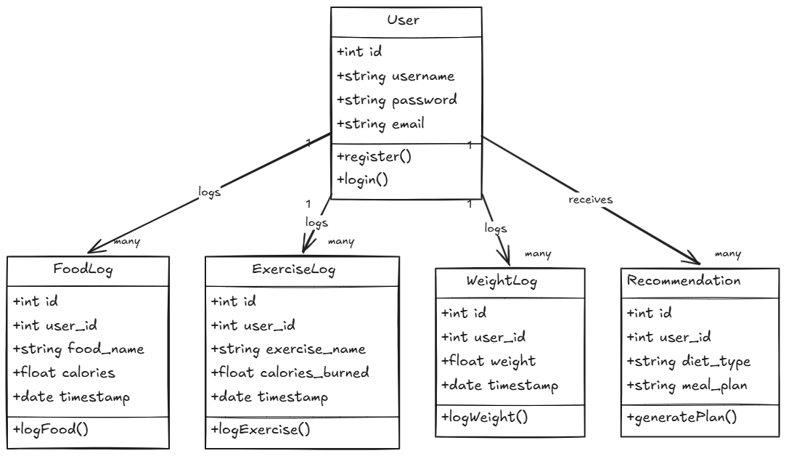

**Data Flow Diagram (DFD) - Level 1**

Illustrates data flow between modules and external entities.

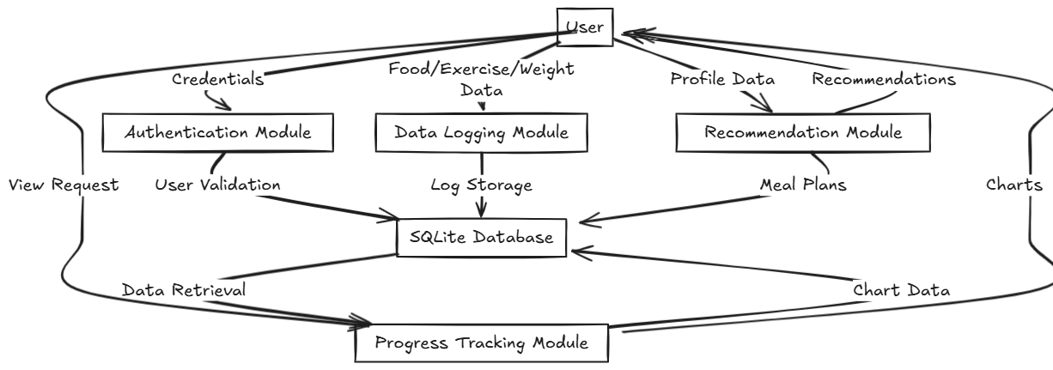

**UML Sequence Diagram**

Shows user interaction for logging food.

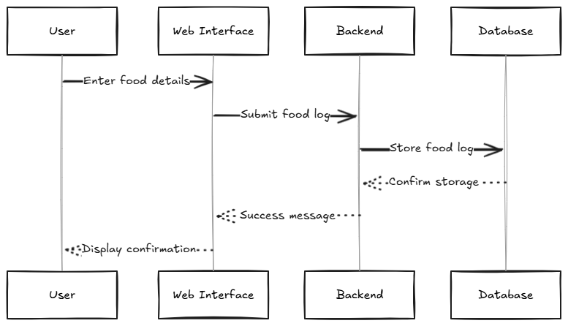

**Other Diagrams**

**1.State Diagram**

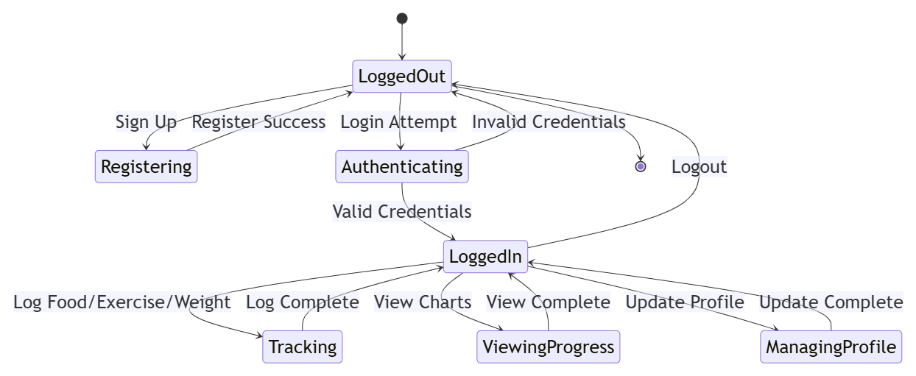

**2.Activity Diagram**

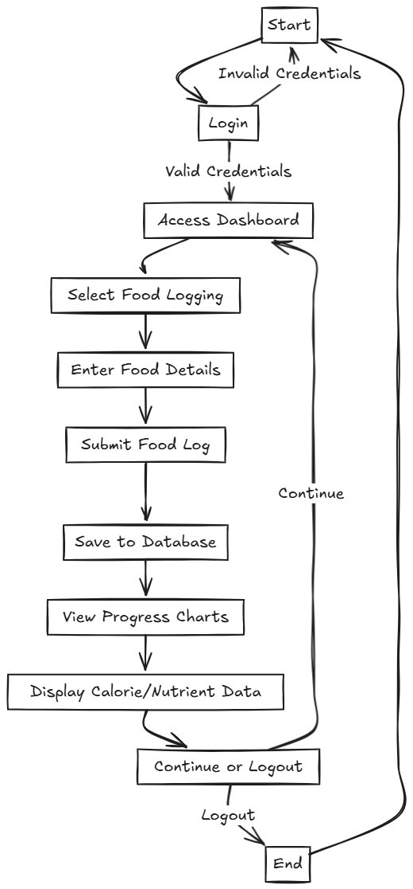

**3.Block Diagram**

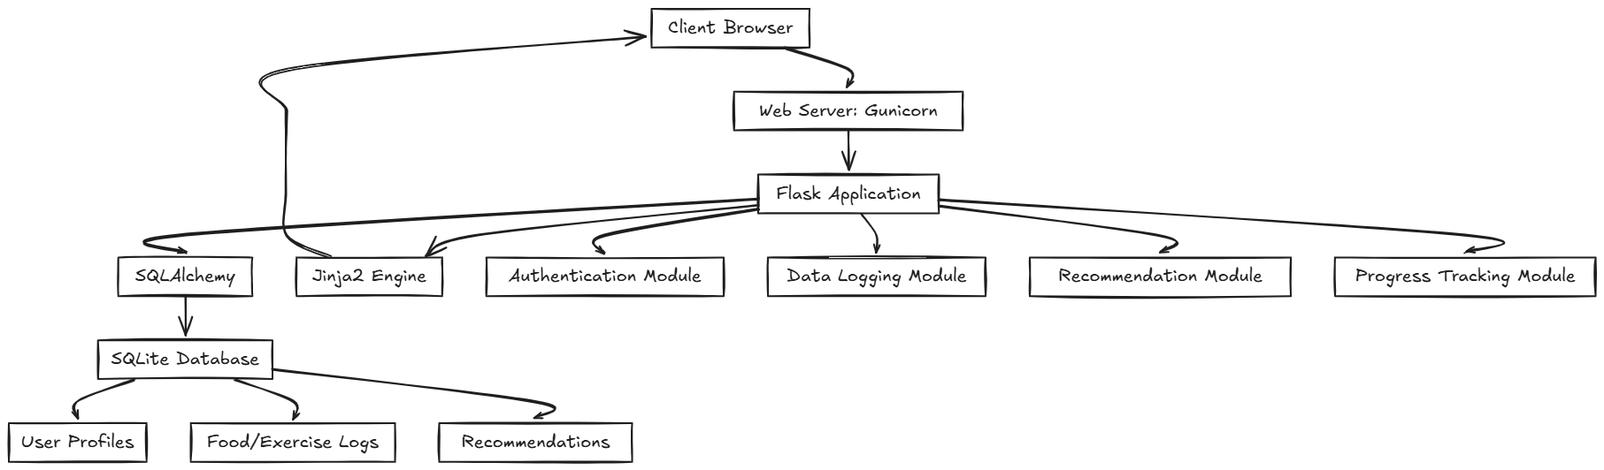

**4.Use Case Diagram**

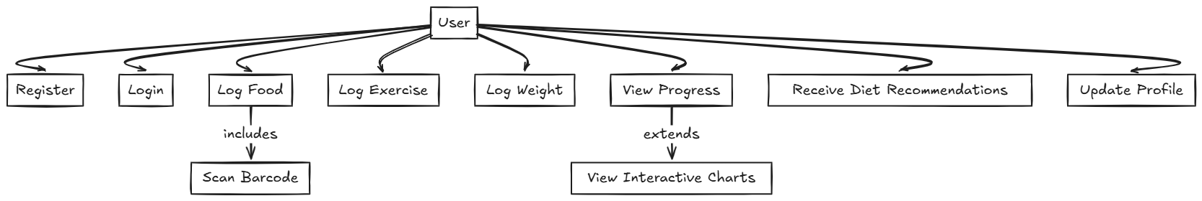

**4.3 Database Design**

The database design for MyNetDiary uses SQLite to store and manage user, food, exercise, and recommendation data, ensuring efficient data logging and retrieval as per Section 3.4 requirements. The design prioritizes simplicity, scalability, and accuracy.

**Entity-Relationship Diagram (ERD)**

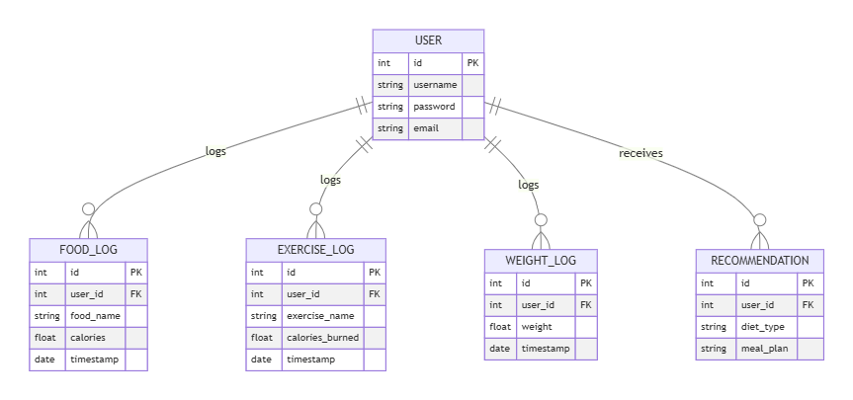

**Key Tables**

* **User**: Stores user credentials (id, username, password, email).
* **Food_Log**: Records food entries (id, user_id, food_name, calories, timestamp).
* **Exercise_Log**: Tracks exercise data (id, user_id, exercise_name, calories_burned, timestamp).
* **Weight_Log**: Logs weight entries (id, user_id, weight, timestamp).
* **Recommendation**: Stores personalized diet plans (id, user_id, diet_type, meal_plan).

**Design Considerations**

* **Normalization**: Tables are in 3NF to minimize redundancy and ensure data integrity.
* **Scalability**: SQLite supports initial needs (<10,000 users); future upgrades to PostgreSQL possible.
* **Security**: Passwords are encrypted; user_id links logs to maintain privacy.
* **Performance**: Indexed user_id and timestamp fields for fast queries (<1 second).

**4.4 System Architecture**

The system architecture for MyNetDiary follows a client-server model, leveraging Flask, SQLAlchemy, and SQLite to deliver a scalable, responsive, and secure web application. It aligns with the modules (Section 4.1) and requirements (Section 3.4), addressing existing system limitations like cross-device inconsistency and security concerns.

**Architecture Diagram**

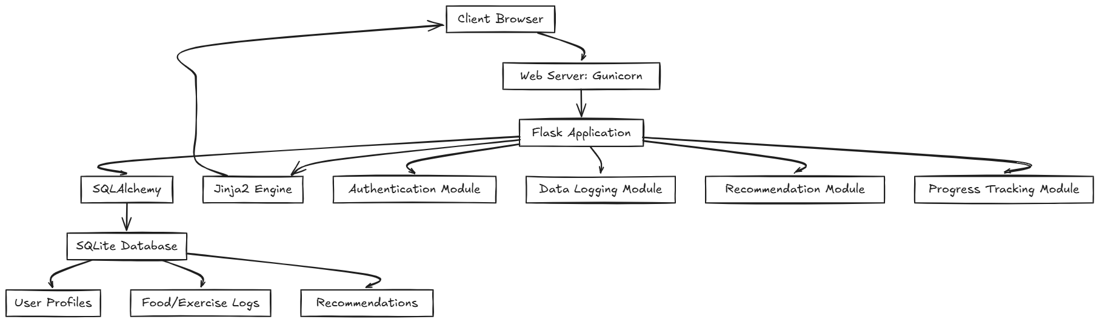

**Components**

* **Client Browser**: Renders responsive UI (HTML/CSS/JS) for user interaction.
* **Web Server (Gunicorn)**: Handles HTTPS requests, ensuring secure communication.
* **Flask Application**: Processes requests, manages logic, and coordinates modules.
* **SQLAlchemy**: Facilitates database interactions with ORM for efficient queries.
* **SQLite Database**: Stores user, log, and recommendation data securely.
* **Jinja2 Engine**: Generates dynamic HTML for the responsive interface.

**Design Features**

* **Scalability**: Supports up to 10,000 users; scalable with load balancers or database upgrades.
* **Security**: Uses HTTPS, encrypted passwords, and session management.
* **Responsiveness**: Ensures compatibility across browsers and devices.

**Chapter 5**

**Project Plan & Schedule**

**5.1 Project Planning and Project Resources**

The development of MyNetDiary requires structured project planning and efficient resource allocation to meet the objectives outlined in Section 1.4 and the requirements in Section 3.4. This section details the project timeline, key milestones, and resources needed for successful implementation within the 3–6 month timeline established in Section 2.3.

**Project Planning**

* **Timeline**: 4 months (16 weeks), divided into phases to ensure timely delivery.
  + **Phase 1: Planning & Design (Weeks 1–3)**:
    - Tasks: Finalize requirements, design architecture, create database schema.
    - Milestones: Approved SRS, architecture diagram, ERD.
  + **Phase 2: Development (Weeks 4–10)**:
    - Tasks: Implement authentication, data logging, recommendation, progress tracking, and UI modules.
    - Milestones: Functional prototype with core features (login, logging, charts).
  + **Phase 3: Testing & Refinement (Weeks 11–14)**:
    - Tasks: Conduct unit, integration, and usability testing; fix bugs.
    - Milestones: Tested application with >90% feature coverage.
  + **Phase 4: Deployment & Documentation (Weeks 15–16)**:
    - Tasks: Deploy to web server (e.g., Heroku), create user guides.
    - Milestones: Live application, completed documentation.
* **Methodology**: Agile with two-week sprints, allowing iterative development and stakeholder feedback.
* **Tools**: Trello for task management, Git for version control, Slack for team communication.

**Project Resources**

* **Human Resources**:
  + **Project Manager** : Oversees planning, coordinates tasks, ensures deadlines.
  + **Developers** : Skilled in Python, Flask, SQLAlchemy, and front-end (HTML/CSS/JS).
  + **UI/UX Designer** : Designs responsive, intuitive interface.
  + **Tester** : Conducts functional and usability testing.
* **Technical Resources**:
  + **Hardware**: Standard laptops (8GB RAM, 256GB SSD) for development and testing.
  + **Software**: Python 3.8+, Flask, SQLAlchemy, SQLite, Jinja2, Visual Studio Code, Postman for API testing.
  + **Hosting**: Local server for development; cloud hosting (e.g., Heroku, $5–$20/month) for deployment.
* **Data Resources**:
  + Food and exercise database (>1.8M entries), sourced from open datasets or APIs (e.g., USDA FoodData Central).

**5.2 Project Scheduling**

Project scheduling for MyNetDiary ensures timely completion within the 4-month (16-week) timeline outlined in Section 5.1, using an Agile methodology with two-week sprints. The schedule is structured into four phases with key tasks and milestones, visualized in the Gantt chart below.

**Schedule Overview**

* **Phase 1: Planning & Design (Weeks 1–3)**:
  + Tasks: Finalize requirements, design architecture, create database schema.
  + Milestone: Approved SRS, architecture diagram, ERD (Week 3).
* **Phase 2: Development (Weeks 4–10)**:
  + Tasks: Implement authentication, data logging, recommendation, progress tracking, and UI modules.
  + Milestone: Functional prototype with core features (Week 10).
* **Phase 3: Testing & Refinement (Weeks 11–14)**:
  + Tasks: Unit, integration, and usability testing; bug fixes.
  + Milestone: Tested application with >90% feature coverage (Week 14).
* **Phase 4: Deployment & Documentation (Weeks 15–16)**:
  + Tasks: Deploy to web server (e.g., Heroku), create user guides.
  + Milestone: Live application, completed documentation (Week 16).

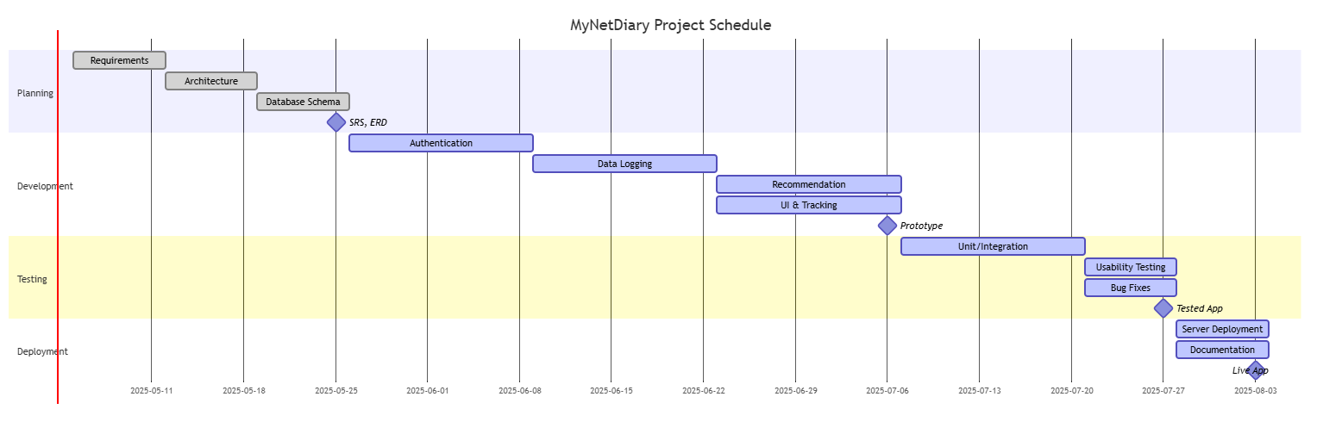

**Chapter 6**

**Risk Management and Analysis**

**6.1 Risk Identification**

Risk identification for MyNetDiary involves recognizing potential issues that could hinder the project’s success, considering its scope (Section 3.1), timeline (Section 5.2), and resources (Section 5.1). The following risks were identified through stakeholder discussions, feasibility analysis (Section 2.3), and lessons from existing systems (Section 2.1).

* Technical Risks:
  + Database Scalability: SQLite may struggle with high user loads (>10,000 concurrent users), impacting performance.
  + Security Vulnerabilities: Weak authentication or data encryption could expose user data.
  + Cross-Browser Compatibility: Inconsistent rendering across browsers (e.g., Safari, Firefox) may degrade user experience.
* Project Management Risks:
  + Schedule Delays: Tight 4-month timeline may be disrupted by unforeseen task complexities.
  + Resource Constraints: Limited team size (2–3 developers) could lead to bottlenecks.
* User Adoption Risks:
  + Low User Engagement: Complex interface or lack of intuitive features may deter users, similar to issues in existing apps (Section 2.1.3).
  + Data Accuracy: Inaccurate food/exercise database entries could undermine trust.
* External Risks:
  + Dependency Issues: Reliance on third-party APIs (e.g., USDA FoodData) may face downtime or data changes.
  + Market Competition: Strong competitors (e.g., MyFitnessPal) may overshadow MyNetDiary’s launch.

**6.2 Risk Analysis**

Risk analysis for MyNetDiary evaluates the risks identified in Section 6.1, assessing their likelihood, impact, and mitigation strategies to ensure project success. Risks are prioritized using a qualitative scale (Low, Medium, High) based on their potential to disrupt the 4-month timeline, budget, or user satisfaction.

Risk Analysis Table

* Database Scalability (Technical):
  + Likelihood: Low (initial user base <10,000).
  + Impact: High (slow queries could disrupt tracking).
  + Mitigation: Optimize queries; plan for PostgreSQL migration if needed.
* Security Vulnerabilities (Technical):
  + Likelihood: Medium (common in web apps).
  + Impact: High (data breaches harm trust).
  + Mitigation: Use HTTPS, bcrypt encryption, regular security audits.
* Cross-Browser Compatibility (Technical):
  + Likelihood: Medium (browser differences).
  + Impact: Medium (affects some users).
  + Mitigation: Test on Chrome, Firefox, Safari; use responsive frameworks (e.g., Bootstrap).
* Schedule Delays (Project Management):
  + Likelihood: Medium (tight timeline).
  + Impact: High (delays launch).
  + Mitigation: Agile sprints, buffer weeks, task prioritization.
* Resource Constraints (Project Management):
  + Likelihood: Medium (small team).
  + Impact: Medium (slows development).
  + Mitigation: Clear task delegation, use open-source tools to reduce workload.
* Low User Engagement (User Adoption):
  + Likelihood: Medium (competition exists).
  + Impact: High (limits adoption).
  + Mitigation: Design intuitive UI, incorporate user feedback, offer free access.
* Data Accuracy (User Adoption):
  + Likelihood: Medium (database sourcing risks).
  + Impact: High (undermines trust).
  + Mitigation: Use verified sources (e.g., USDA), implement data validation.
* Dependency Issues (External):
  + Likelihood: Low (reliable APIs).
  + Impact: Medium (delays data access).
  + Mitigation: Cache data locally, maintain backup sources.
* Market Competition (External):
  + Likelihood: High (strong competitors).
  + Impact: Medium (affects visibility).
  + Mitigation: Highlight unique features (free access, personalization), leverage social media.

**References**

**References**

[1] L. E. Burke, J. Wang, and M. A. Sevick, "Self-monitoring in weight loss: A systematic review of the literature," *J. Amer. Dietetic Assoc.*, vol. 111, no. 1, pp. 92–102, Jan. 2011. doi: 10.1016/j.jada.2010.10.008.

[2] J. Chen, W. G. Gemmell, and M. T. Cade, "Effectiveness of smartphone-based dietary tracking apps," in *Proc. IEEE Int. Conf. Health Informatics*, Chicago, IL, USA, 2018, pp. 123–130. doi: 10.1109/ICHI.2018.00023.

[3] J. R. L. Lieffers, J. E. Vance, and R. M. Hanning, "Use of mobile device applications in Canadian dietetic practice," *Can. J. Dietetic Practice Res.*, vol. 75, no. 1, pp. 41–47, Mar. 2014. doi: 10.3148/75.1.2014.41.

[4] Healthline, "The 8 best calorie counter apps of 2025," Healthline, Jan. 2025. [Online]. Available: https://www.healthline.com/nutrition/best-calorie-counters

[5] CNET, "Best nutrition apps for 2025," CNET, Jan. 2025. [Online]. Available: https://www.cnet.com/health/nutrition/best-nutrition-apps/

[6] Forbes, "The best calorie counter apps to track diet and fitness goals in 2025," Forbes, Jan. 2025. [Online]. Available: https://www.forbes.com/sites/forbes-personal-shopper/article/best-calorie-counter-apps/

[7] USDA, "FoodData Central," U.S. Department of Agriculture, 2025. [Online]. Available: https://fdc.nal.usda.gov/

[8] IEEE, *IEEE Standard for Software and System Test Documentation*, IEEE Std 829-2008, 2008. doi: 10.1109/IEEESTD.2008.4578383.